GUI DESIGNERS
Web Service Briefing

Introduction
This briefing provides a summary of the three stages involved in creating a successful Internet presence, and the Web Services that we deliver to our clients together with examples of the sites that we have created.

Site Design and Construction
This section outlines the issues involved in designing and construction a Web Site.

Site Purpose
To be effective, a site must have a clearly defined purpose and audience. The purpose can range from simply announcing the existence of a company to providing a complete information and sales channel for employees, distributors and customers.

GUI Designers’ first step in developing your Web presence is to work with you to define its goals and audience. This information enables us to agree with you the type of Web site that will be of most benefit to your organisation and clients.

Web sites typically fall into three categories:

Simple Web Presence comprising a “home” page providing a simple overview of a company, and a “contacts” page that enables potential clients to contact the company, typically using e-mail.

Products and Services Site which includes a number of “zones” that describe the company, its products and provide contact details. These sites include product support information.

E-Sites which are a natural progression from Product and Services sites, are more closely integrated with the clients sales and support functions. Such sites can provide a variety of services including accepting orders for customers, providing feedback about the status of orders, and generating lists of clients who are interested in receiving new product information.

Content
Our philosophy is that good content is central to the success of a Web site. In the context of the Web, good content is:
▪ Informative
▪ Up to date
▪ Brief
- Visually attractive.

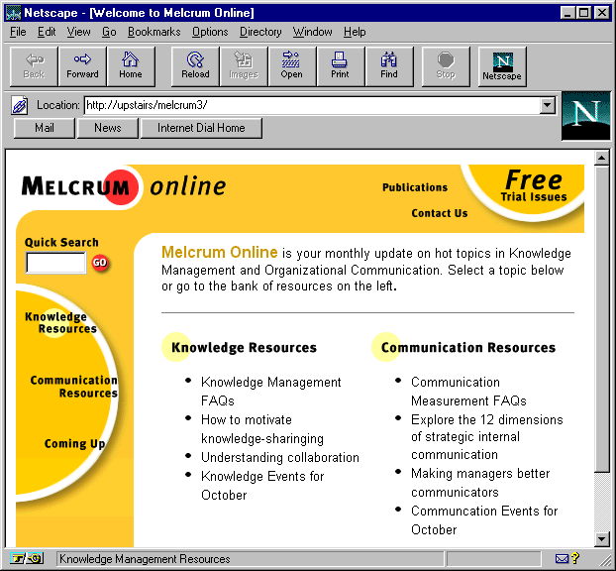
Melcrum Online, created by GUI Designers
We work closely with our clients to ensure that our work promotes their products and brand identity. We are also happy to work with existing advertising departments or agencies.

In our experience, brochures can often act as a starting point for Site content. However, the prose and graphic elements usually have to be reworked to gain best effect within a Web Site.

Cost Guidelines
Clearly, the content of every site that we build is different. The table below provides guidelines on the typical cost of the types of site that we described above.

 | From…
Web Presence | £ 1000
Product and Services | £1,500
E-Site | £ 5,000

Hosting
Once built, the Web Site must be “hosted” on a Web Server. This section describes the process of hosting a Web Site.

Site Name
Web sites are identified by a unique name or address (URL) which conform to a standard format. Site addresses have to be registered with a fee charging administrative body which ensures that no two sites have the same address.

As part of our hosting service, we check on the availability of suitable addresses, and register your chosen address.

Web Space
Web Sites are hosted on computers that are connected to the Internet. The simplest route to creating a public Web Site is to host it on a Web server operated by third party Company known as an Internet Service Provider (ISP). An ISP hosts a Site for an annual fee, which depends on the size of the Web Site, and the range of services that it requires.

GUI Designers are happy to arrange Web Site hosting with our recommended ISP.

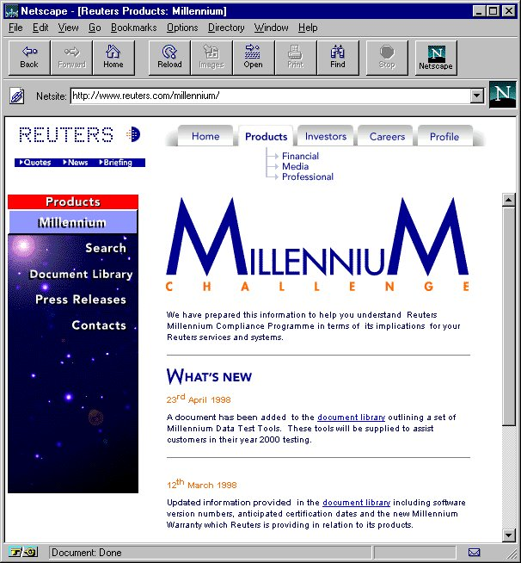
Reuters Millennium Web Site designed by GUI Designers

E-Mail
The usual mechanism for visitors contacting you from your Web-Site is e-mail.
Examples of e-mail address are:
- Info@gui-designers.co.uk
- RHeath@gui-designers.co.uk

Your choice of e-mail addresses can be arranged for you.

E-mail can be retrieved and replied to using a number of simple PC packages such as Microsoft Internet Explorer.

Where required, GUI Designers will provide training and support in setting up and using e-mail packages.

Internet Search Engines
Web Sites are often found as a result of visitors using an Internet Search Engine. The major search engines are:
▪ AltaVista
▪ Yahoo
▪ Excite
As part of our Web Service, we will register your site with these search engines.

Cost Guidelines

 | Cost
Site Address Registration and Hosting Per Year | From £ 175
Registration with three search engines | Free
Registration with additional search engine(s) | £ 75 per engine

Maintenance
To remain effective, a site must be maintained. This section describes those aspects of a site that require maintenance.

Content
To be effective, the content of a Web Site must be kept up to date. New information should be added at roughly monthly intervals. This can be achieved by including a “News” area within the site.

GUI Designers can keep the site up to date on your behalf by adding new information to the site at your request. However, we recommend that for minor changes it is more effective for you to maintain the site. To this end, we offer a one-day Site Maintenance Tutorial.

Where updates require new areas to be added to the site, we will provide you with a quotation for the design and implementation work that you require.

Integrity
Where a Web Site contains links to other Sites, it is important to ensure that the links remain up to date. The changing nature of the Web means that Sites frequently disappear or are renamed.

Again, we recommend that our clients maintain their own Web Site links, however, we can offer this facility as part of our Update Service.

Cost Guidelines

 | Typical Cost
Minor Text Updates | £ 25 - £ 100
On-Site Maintenance Tutorial | £ 400 for 2 delegates
Re-Design | As for Site Design

Example Sites

This section provides representative examples of Web sites created by GUI Designers.

Melcrum Online
URL: http://www.melcrum.com

Laytons Solicitors
In Development

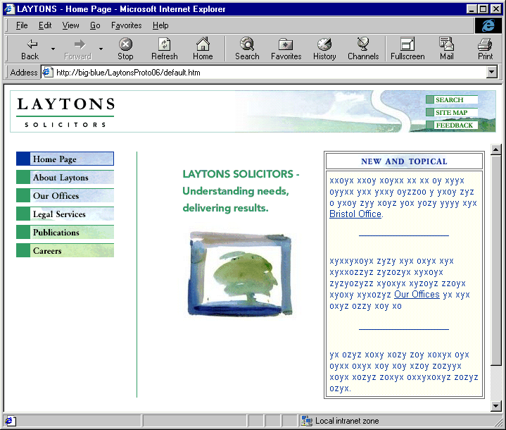

GUI Designers Home
URL: www.gui-designers.co.uk

